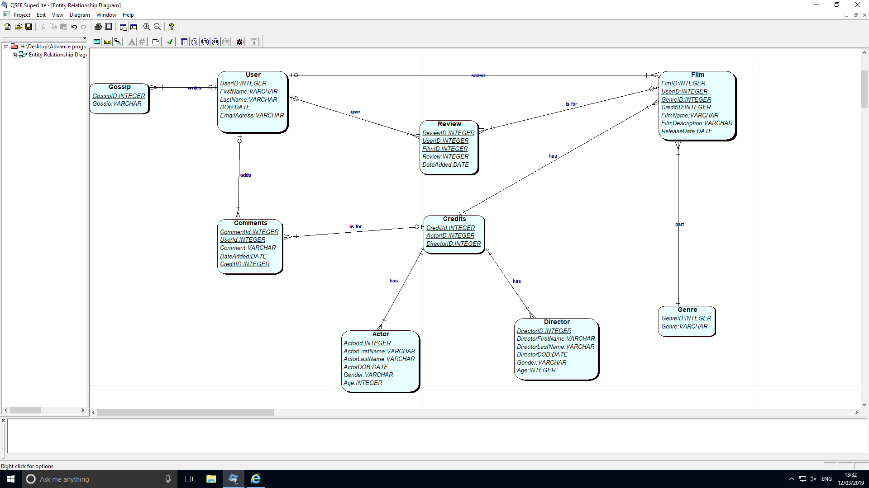

**Table Definition**

**Gossip** (**GossipID**, Gossip)

**User** (**UserID**, FirstName, LastName, DOB, EmailAddress,)

**Review** (**ReviewID**, *UserID, FilmID*, Review, DateAdded)

**Film** (**FilmID**, *UsreID,* *GenreID, CreditID*, FilmName, FilmDescription, ReleaseDate,)

**Genre** (**GenreID,** Genre)

**Comment** (**CommentID**, *UserID*, Comment, DateAdded, *CreditID*)

**Credit** (**CreditID**, **ActorID**, **DirectorID**)

**Actor** (**ActorID,** ActorFirstName, ActorLastName, ActorDOB, Gender, Age)

**Director** (**DirectorID,** DirectorFirstName, DirectorLastName, DirectorDOB, Gender, Age)